The next workshop in the British Liquid Crystal Society (BLCS) Annual Training Workshops series will be held on an online platform on 7-8 January 2021. The two-day event will include a mixture of “live” and pre-recorded lectures, discussion hours and modelling training sessions, and a mini-symposium. The workshop is intended for early-stage researchers (primarily PhD students, but also post-doctoral research associates and researchers in industry, relatively new to the field of liquid-crystal research, irrespective of their academic disciplines). The workshop when held in traditional setup can offer only limited number of places.
The BLCS Annual Training Workshops are intended to provide education and training for the next generation of researchers in the highly interdisciplinary area of liquid-crystal research, highlighting its recent advances in the wider context of soft and biological matter. This long-running series of workshops was reinvigorated when it was held at the University of Birmingham for the first time in 2020, with the inclusion of a mini-symposium “Liquid-Crystal Research in the 2020s”. The mini-symposium will be focused on discussing emerging questions and open problems in liquid-crystals research and at its interfaces.
Expression of Interest
Expression of Interest for attending the BLCS Annual Training Workshop to be held online on 7-8, January 2021 should be emailed to blcs-atw@contacts.bham.ac.uk by December 14, 2020 in the prescribed format given below. There is no registration fee for accepted participants.

Programme
The final programme will be made available here in due course. The list of speakers confirmed so far is as follows:
Dr Dwaipayan Chakrabarti
Prof. Cliff Jones
Prof. Apala Majumdar
Prof. Georg Mehl
Prof. Nigel Mottram
Dr Mamatha Nagaraj
Prof. Jon Preece
Prof. Ivan Smalyukh
Prof. Gordon Tiddy
Prof. Mark R. Wilson
Prof. Julia Yeomans

Scientific Organising Committee Dr Dwaipayan Chakrabarti (Co-Chair) Prof. Apala Majumdar (Co-Chair) Dr Susanne Klein Prof. Jon A. Preece
Sponsors & Partners
We are very thankful to our sponsors and partners:
British Liquid Crystal Society


EPSRC
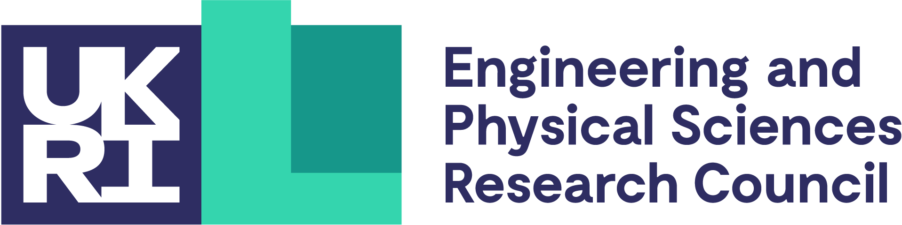

UK Fluids Network

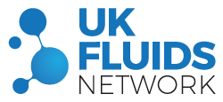

University of Birmingham
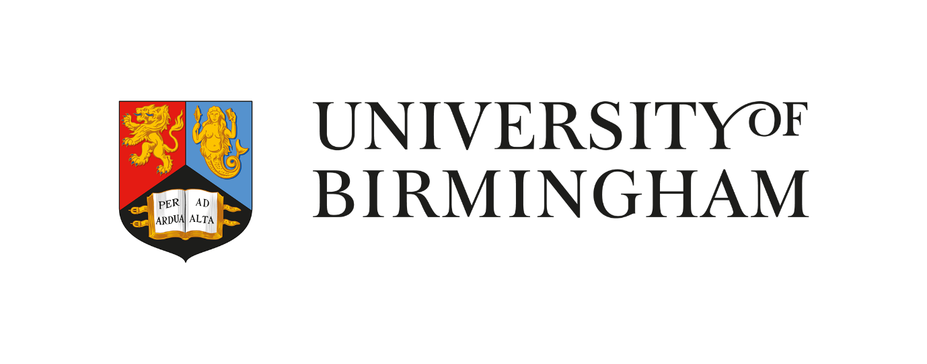
Contact us
For all enquiries about the BLCS Annual Training Workshops, please email at blcs-atw@contacts.bham.ac.uk.

Expression of Interest form – The 2021 British Liquid Crystal Society Annual Training Workshop

Return instructions

Please email the completed Expression of Interest for attending the BLCS Annual Training Workshop to be held online on 7-8, January 2021 to blcs-atw@contacts.bham.ac.uk by December 14, 2020.

Please follow the format below.

- Surname:

- Forename:

- Affiliation:

- E-mail address:
Confirm e-mail address:

- Career stage:
PhD Student / Post-Doctoral Research Associate / Researcher in Industry / Other
If ‘other’, please specify:

- Research supervisor(s):

- Current area of research:

- Reason to attend the BLCS Annual Training Workshop:

- Please specify if currently funded by an EPSRC grant:

- Additional information:

